## User Interface Design

### Guest Interface Design

#### Login

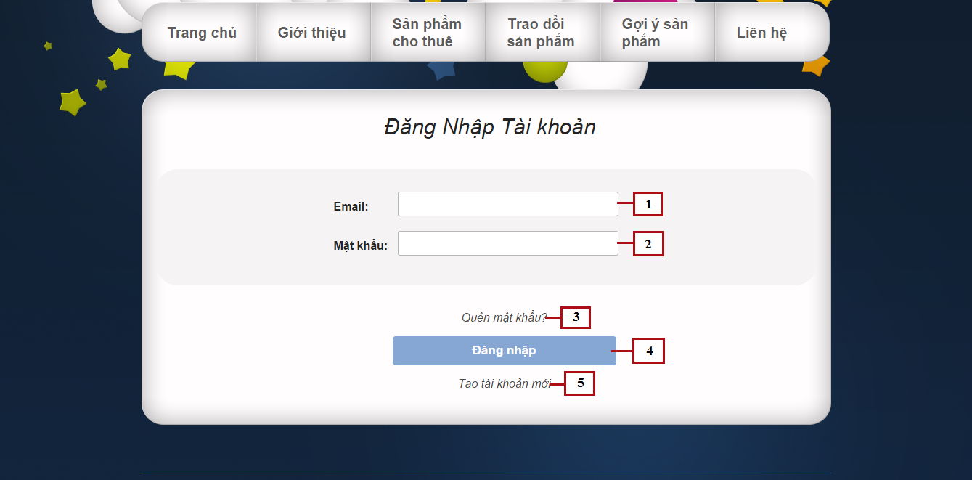

Figure 106: Login

**Fields**

|  |  |  |  |  |  |  |  |
| --- | --- | --- | --- | --- | --- | --- | --- |
| **No** | **Field Name** | **Description** | **Read only** | **Mandatory** | **Control Type** | **Data Type** | **Length** |
| 1 | Email | Fill user email | No | Yes | Textbox | String | N/A |
| 2 | Password | Fill password | No | Yes | Password | String | [8-32] |

**Buttons/Hyperlinks**

|  |  |  |  |  |
| --- | --- | --- | --- | --- |
| **No** | **Function** | **Description** | **Validation** | **Outcome** |
| 3 | Forget password | Click when forget password, to request new password | N/A | N/A |
| 3 | Login | Click to login into the system | Yes | Transfer to home page |
| 5 | Register | Click to register a new account | N/A | Transfer to register page |